**Market Segmentation**

**Electric Vehicle (EV) Market Segmentation**

**Submitted By: Anubha Sharma**

[Project Link :https://github.com/AnubhaSharma2709/Electric-vehicle-Case-study.git](https://github.com/AnubhaSharma2709/Electric-vehicle-Case-study.git)

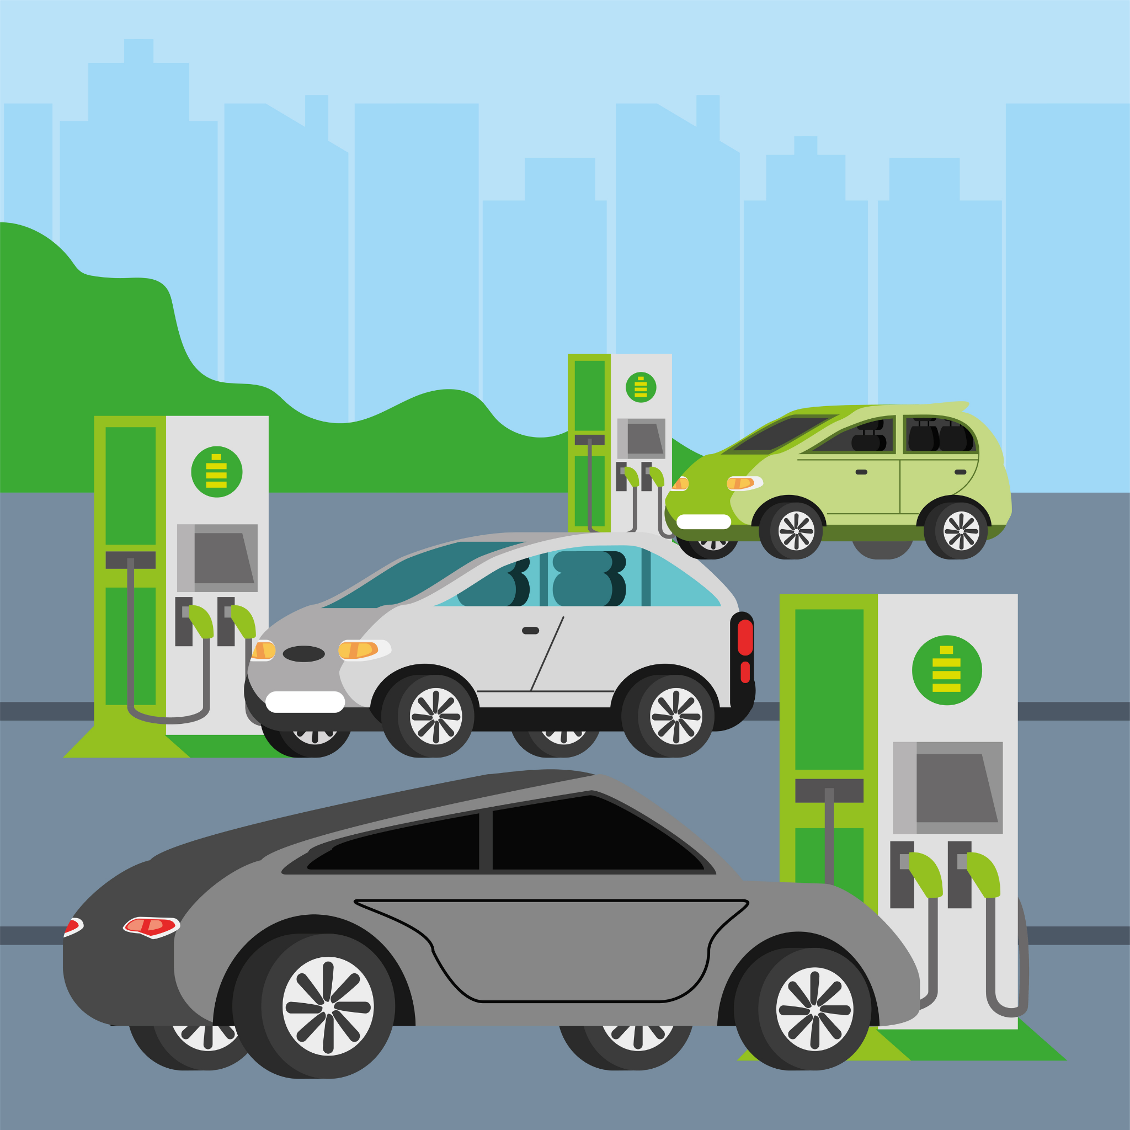

**[Image Source :** [**https://static.vecteezy.com/system/resources/previews/004/205/576/original/electric-cars-in-station-vector.jpg**](https://static.vecteezy.com/system/resources/previews/004/205/576/original/electric-cars-in-station-vector.jpg) **]**

**Fermi Estimation for Market Segmentation in India's Electric Vehicle Market**

**1.1 Market Potential for Electric Vehicles**

The estimation indicates a substantial market potential for electric vehicles (EVs) in urban areas of India, considering the significant population density and potential for vehicle ownership

| **Total Population** | Population Estimate: Approximately 1.4 billion people |
| --- | --- |
| **Percentage of Urban Population** | Estimate: Around 30% of India's population resides in urban areas |
| **Vahicle Ownership Rate in Urban Area** | Assume 1 vehicle for every 4 urban residents. |
| **Potential EV Urban Market** | Estimated User  105 million potential urban EV users |

**1.2 Psychographic Segmentation:**

| **Environmental Consciousness** | * Estimate: 40% of urban population prioritize eco-friendly products. * This segment may include individuals who are concerned about environmental sustainability and seek products that have minimal impact on the environment. They are likely to be receptive to EVs due to their eco-friendly nature. |
| --- | --- |
| **Technology Enthusiasts** | * Assume: 60% of urban population are early adopters of new technology. * This segment comprises individuals who are keen on embracing innovative technologies and are often the first to adopt new products and services. They may perceive EVs as cutting-edge technology and be willing to try them out. |
| * **Behavioral Segmentation** | * **Commuting Habits**: * Estimate: 50% of urban population commute less than 30 km daily. * This segment consists of individuals with short commuting distances, making them potential candidates for EV adoption due to the suitability of EVs for short-distance travel. * **Parking Facilities**: * Assume: 70% of urban residents have access to private parking. * Access to private parking facilitates EV ownership as it allows for convenient charging at home. This segment represents individuals who have the infrastructure necessary for EV ownership. |
| **Geographic Segmentation** | * **Focus Cities**: * Identify Delhi, Mumbai, Bangalore, Chennai, Kolkata, Hyderabad, Pune, Ahmedabad, Surat, and Jaipur. * These metropolitan areas have the highest vehicle density and are likely to exhibit higher demand for EVs due to factors such as traffic congestion and pollution levels. * **Tier 2 Cities**: * Consider Indore, Chandigarh, Lucknow, Kochi, Bhopal, Visakhapatnam, Nagpur, Coimbatore, Vadodara and Patna. * Tier 2 cities with emerging infrastructure present opportunities for expansion, as they may experience increasing urbanization and vehicle ownership rates, coupled with growing awareness of environmental issues. |
| **Demographic Segmentation** | * **Age Groups** * Estimate: 30% of urban population falls within 25-40 age bracket, likely early adopters. * Younger demographics within the 25-40 age range are often more open to adopting new technologies and are likely to be early adopters of EVs. |
| **Occupations** | * Assume: 20% of professionals such as IT workers and consultants are interested in EVs.Professionals with higher disposable incomes and a penchant for technology are potential customers for EVs, as they may prioritize environmental consciousness and seek innovative transportation solutions. |

By segmenting the market based on psychographic, behavioral, geographic, and demographic factors, we can tailor marketing strategies and product offerings to meet the diverse needs and preferences of different consumer segments, thereby maximizing the effectiveness of our market entry strategy in India's electric vehicle market.

# Data Sources for Electric Vehicle Market Analysis:

# 1. Electric Vehicle Models Dataset (dataset_1)

# Provides details on electric vehicle models in India, including specifications and pricing.

# Crucial for understanding the current EV landscape and identifying competitors.

**Source** [**https://www.kaggle.com/datasets/kkhandekar/electric-vehicles-india**](https://www.kaggle.com/datasets/kkhandekar/electric-vehicles-india)

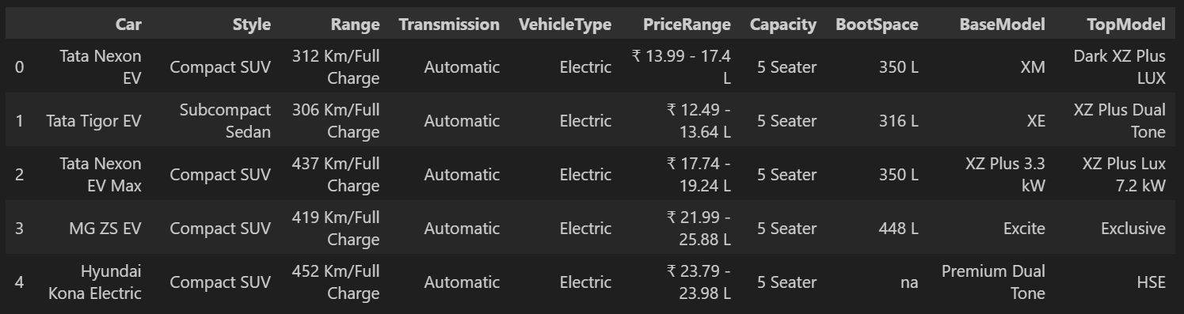

# 2. Indian Automobile Buying Behavior Study Dataset (dataset_2)

# Contains demographic and socio-economic info of car buyers in India.

# Helps in segmenting market and predicting EV adoption based on buyer behavior.

# Source- <https://www.kaggle.com/datasets/karivedha/indian-consumers-cars-purchasing-behaviour>



# 3. State-wise Electric and Non-electric Vehicle Registrations Dataset (dataset_3)

# Presents statistics on electric and non-electric vehicle registrations by state.

# Essential for assessing regional EV adoption trends and identifying growth opportunities.

# Source- <https://data.gov.in/search?title=Electric%20Vehicles>

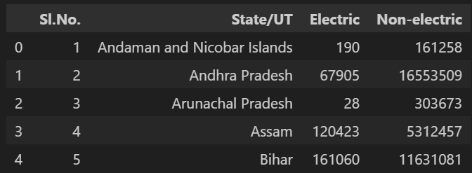

# These datasets offer comprehensive insights into various aspects of the electric vehicle market in India. By analyzing electric vehicle models, buyer behavior, and regional registrations, we can formulate effective strategies for market entry, segmentation, and expansion. Leveraging this data allows for informed decision-making and targeted approaches to capitalize on the growing demand for electric vehicles in India.

# Data Preprocessing for Electric Vehicle Market Analysis

Based on the Dataset we have explored that The Top 10 States with Maximum Electric Vehicles are: Uttar Pradesh Maharashtra Karnataka Delhi Rajasthan Tamil Nadu Bihar Gujarat Assam Kerala.

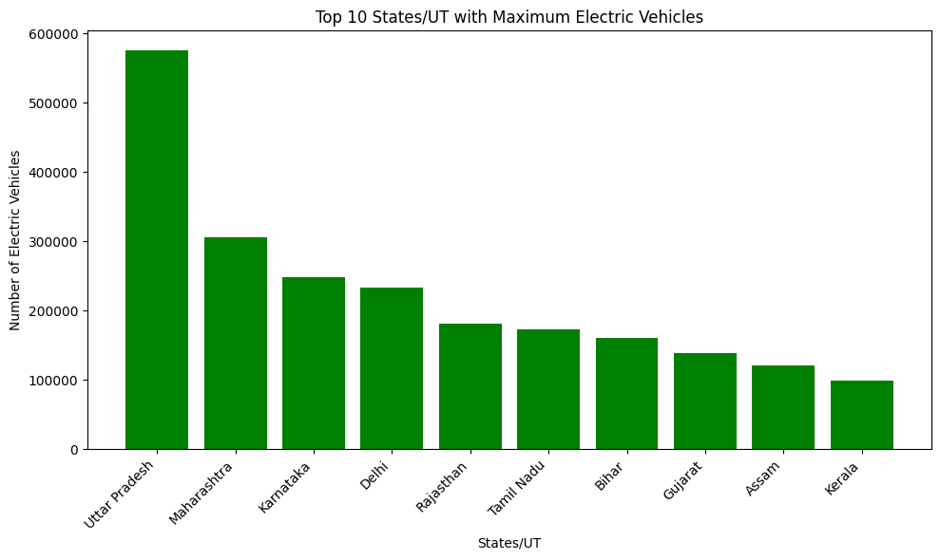

The maximum people buying cars in India lies in the age groups of 30-45 years, with the highest percentage falling in the 35-40 age group.

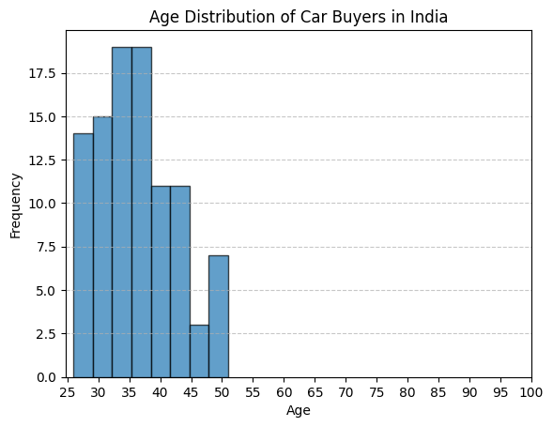

Among married people with three or more dependents, the distribution of cars makes shows that Baleno are the most popular choice, followed by SUVs and Creata.

Based on the observation that married individuals with three or more dependents tend to prefer SUVs, it suggests that manufacturing an Electric SUV could be a lucrative option for the company to target this specific demographic segment.

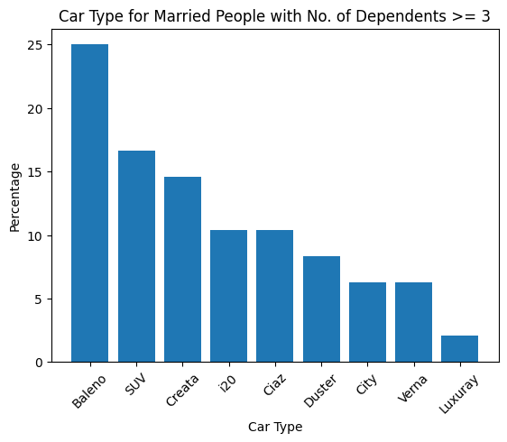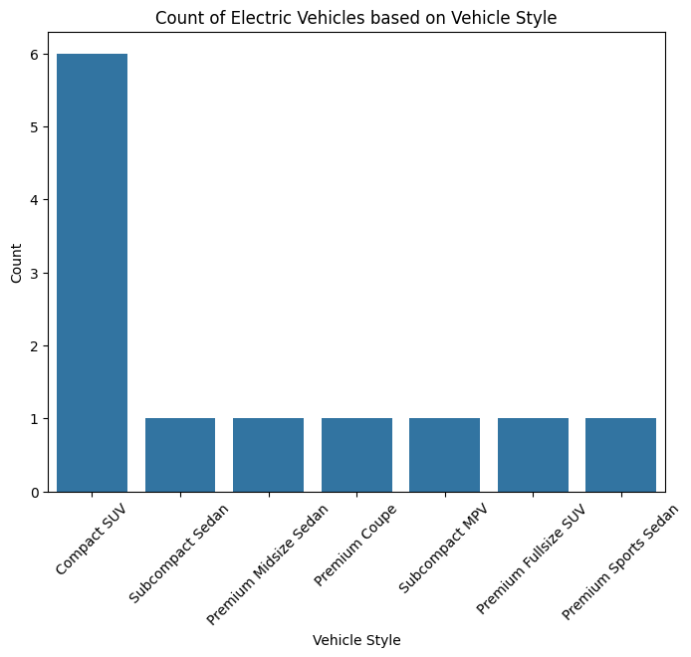

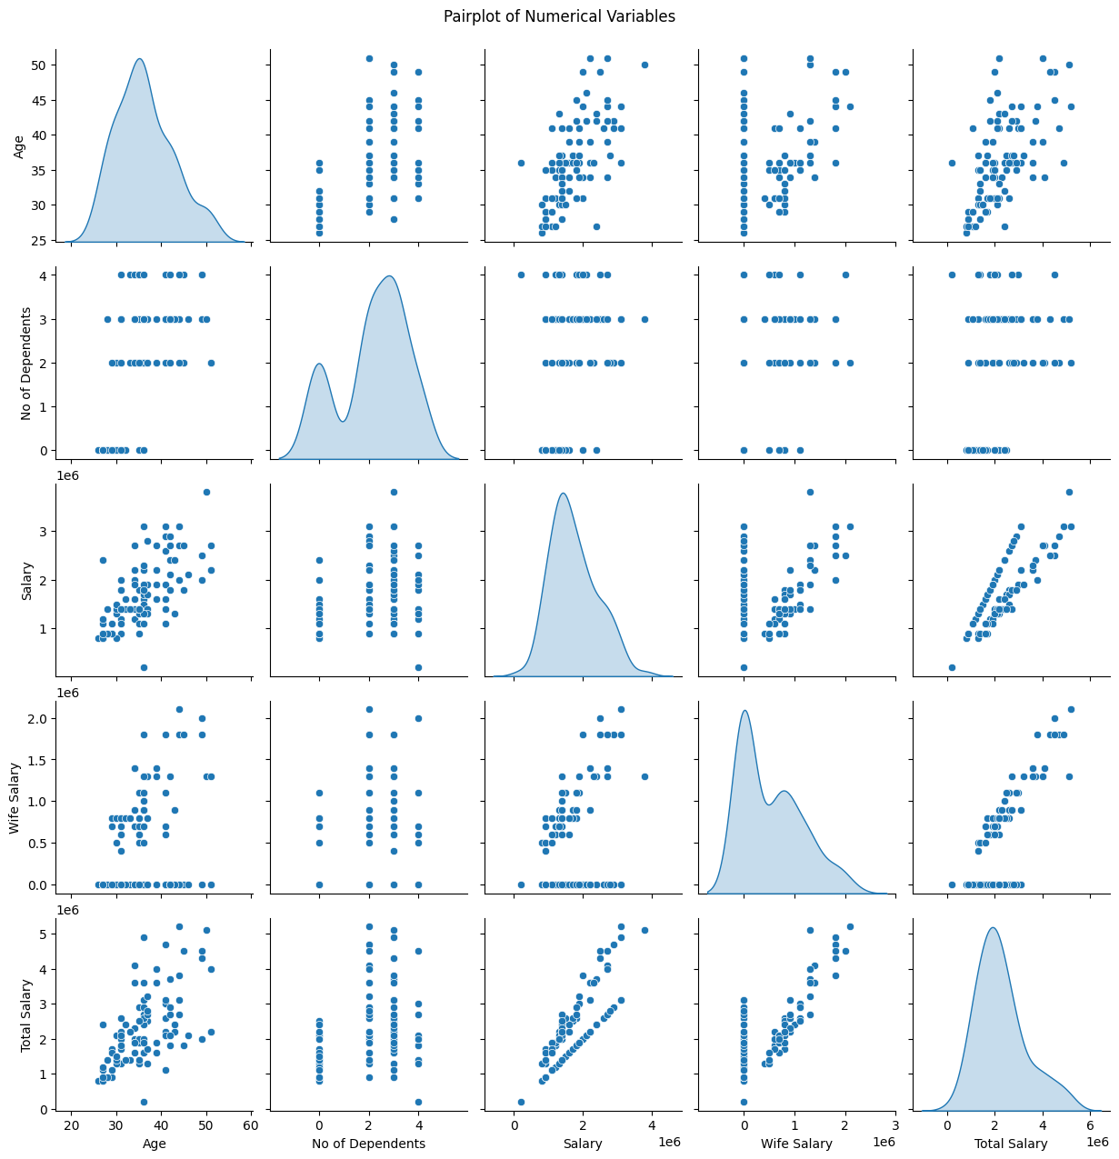

**Pair Plot showing the relation of various columns in the Car Purchasing Behavioural Dataset**

**Segment Extraction (ML techniques used)**

Based on the Elbow Method analysis conducted on our dataset, we determined that the optimal number of clusters for the K-Means algorithm is 4.

This conclusion was drawn by observing the inertia plot, where the rate of decrease in inertia slowed significantly after reaching four clusters.

Therefore, we will use ( k = 4 ) to segment our data into four distinct clusters, enabling us to identify meaningful patterns and segments within the dataset.

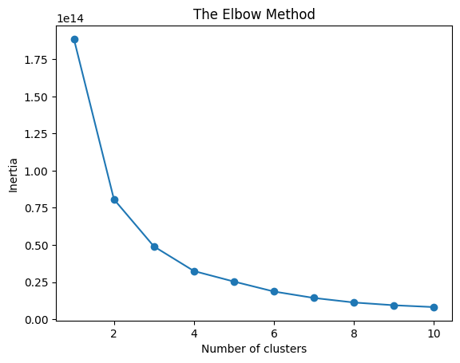

**Profiling and Describing Potential Segments**

Prior to analysis, categorical data is transformed into numerical format to ensure compatibility with clustering algorithms. This involves mapping categorical values to numerical equivalents:

profession_dict = {'Salaried': 0, 'Business': 1}

marital_status_dict = {'Married': 1, 'Single': 0}

education_dict = {'Post Graduate': 1, 'Graduate': 0}

yes_no_dict = {'Yes': 1, 'No': 0}

# Remove rows with unclear or invalid data (if any)

dataset_2_cleaned = dataset_2[dataset_2['Wife Working'] != 'm']

# Map dictionaries onto dataset columns

dataset_2_cleaned['Profession'] = dataset_2_cleaned['Profession'].map(profession_dict)

dataset_2_cleaned['Marrital Status'] = dataset_2_cleaned['Marrital Status'].map(marital_status_dict)

dataset_2_cleaned['Education'] = dataset_2_cleaned['Education'].map(education_dict)

dataset_2_cleaned['Personal loan'] = dataset_2_cleaned['Personal loan'].map(yes_no_dict)

dataset_2_cleaned['House Loan'] = dataset_2_cleaned['House Loan'].map(yes_no_dict)

# Convert 'Make' column to numerical values

make_dict = {'SUV': 0, 'Baleno': 1, 'Creata': 2, '20': 3, 'Ciaz': 4, 'City': 5, 'Duster': 6, 'Verna': 7, 'Luxuary': 8}

dataset_2_cleaned['Make'] = dataset_2_cleaned['Make'].map(make_dict)

# Drop unnecessary columns if needed

dataset_2_cleaned = dataset_2_cleaned.drop(columns=['Price'])

Understanding the distinct segments within the dataset is crucial for effective targeting and marketing strategies. Here, we employ a segment profile plot to elucidate the characteristics of each segment. This plot is generated through hierarchical clustering of segmentation variables followed by visualization in a bar graph.

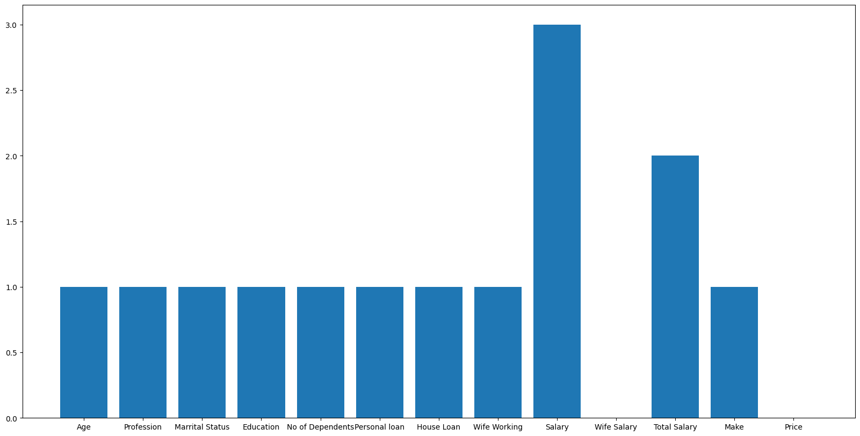

* Segment 0: Age, Profession, Marital Status, Education, No of Dependents, Personal Loan, House Loan, Wife Working, Make.
* Segment 1: Profession.
* Segment 2: Total Salary.
* Segment 3: Salary.

**Selection of Target Segment**

The target segment selection is a critical decision that significantly impacts the success of a business. After conducting a thorough analysis, it is evident that Segment 2 is the most suitable target segment for the electric vehicle (EV) startup company.

Several factors support this decision:

1. **High Financial Status**: Consumers in Segment 2 exhibit a higher financial condition compared to other segments. This indicates their ability to afford electric vehicles, making them a lucrative target market.
2. **Age Demographics:** The average age within Segment 2 aligns with the demographic most likely to purchase EVs, particularly individuals aged between 30 to 45 years.
3. **Stable Income:** A significant proportion of consumers in Segment 2 are salaried individuals, implying a stable income and a higher likelihood of purchasing EVs.
4. **Preference for SUVs:** The preferred car type in Segment 2 is SUVs. As the EV startup focuses on manufacturing electric SUVs, it aligns perfectly with the preferences of this segment.

**Customizing the Marketing Mix (Potential Customer Base in the Early Market)**

To estimate the potential sales (profit) in the early market, the following calculations are made:

**1. Electric 2-Wheeler**

- Average price per unit: ₹100,000

- Estimated units sold: 425,000

- Potential Profit in India: ₹42.5 Billion

**2. Electric 3-Wheeler**

- Average price per unit: ₹200,000

- Estimated units sold: 150,000

- Potential Profit in India: ₹30 Billion

**3. Electric 4-Wheeler:**

- Average price per unit: ₹1,500,000

- Estimated units sold: 50,000

- Potential Profit in India: ₹75 Billion

By focusing on Segment 2 and customizing the marketing mix based on potential customer base, the EV startup can effectively penetrate the market and achieve significant profitability in the early stages.

**The MOST OPTIMAL MARKET SEGMENTS**

Based on the comprehensive market research and segmentation analysis, the most optimal market segments for establishing an Electric Vehicle (EV) startup in India can be identified through geographic and demographic factors.

**Geographic Segments:**

1. **Uttar Pradesh:** With a high demand for EVs and supportive infrastructure including charging stations, Uttar Pradesh presents a lucrative market opportunity for EV startups.
2. **Delhi:** Being a highly urbanized region with significant environmental concerns, Delhi offers a considerable market for EVs. Additionally, government subsidies and incentives further encourage the adoption of electric vehicles.
3. **Karnataka:** With a growing tech-savvy population and supportive government policies, Karnataka is emerging as a promising market for EVs. The presence of infrastructure and subsidies enhances the feasibility of establishing an EV startup in the state.
4. **Maharashtra:** As a leading state in terms of EV sales and infrastructure development, Maharashtra provides a favorable environment for EV startups. The presence of charging stations and government support adds to its attractiveness.

**Feasible Strategy:**

1. **Focus on High-Demand States**: Concentrating efforts on states with a higher demand for EVs, such as Uttar Pradesh, Delhi, Karnataka, and Maharashtra, can lead to faster market penetration and higher sales.
2. **Leverage Existing Infrastructure**: Setting up the startup in states with existing infrastructure, including charging stations, can streamline the operational process and reduce setup costs.
3. **Government Subsidies and Incentives**: Take advantage of government subsidies and incentives available in these states to further promote the adoption of electric vehicles among consumers.
4. **Product Focus**: Develop EV 2-wheelers and SUVs as they align with the preferences of the target demographic identified through market segmentation analysis. This strategic product focus will attract a larger potential customer base and drive early market growth.

In addition to strategic targeting and product alignment, the EV startup can further enhance its positioning for success by implementing the following strategies:

1. **Innovative Marketing:**  Utilize creative campaigns across multiple channels to educate and excite consumers about EVs.
2. **Customer Engagement:** Prioritize customer education, seamless purchasing, and exceptional after-sales service.
3. **Product Differentiation:** Continuously innovate EV offerings to stay ahead, emphasizing unique features and benefits.
4. **Sustainability Focus:** Highlight environmental benefits and integrate eco-friendly practices into operations.
5. **Partnerships:** Collaborate with industry players and stakeholders to accelerate market growth and infrastructure development.

By integrating these strategies into its business model, the EV startup can strengthen its market positioning, drive customer acquisition and retention, and capitalize on the burgeoning demand for electric vehicles in India. Ultimately, by prioritizing customer-centric approaches, innovation, and sustainability, the startup can establish itself as a leader in the Indian EV market and contribute to the transition towards a cleaner and greener transportation future.